Ganpati Utsav 2025 Nashik Bandobast Plan (AI Mapped)

SECTION 1 – INTRODUCTION & OVERVIEW
1.1 Objective
- To ensure the peaceful, safe, and smooth conduct of Ganpati Utsav 2025 from 25 Aug to 8 Sep in Nashik City.
- Primary goals: Public safety, crowd control, traffic regulation, prevention of crimes, effective emergency response, and welfare of deployed forces.
1.2 Key Dates
Date | Event | Remarks
25–26 Aug | Early Agman processions | Medium crowd
27 Aug | Ganesh Chaturthi (Main Agman Day) | Very high crowd; citywide processions
28 Aug–4 Sep | Daily darshan, cultural events | Variable crowd
5 Sep | Eid overlap | High security requirement
6 Sep | Pre-Visarjan | Increased deployments
7–8 Sep | Main & residual Visarjan | Max deployment; immersion till 3 AM on 8 Sep

1.3 Administrative Structure
- CP → Zones (2) → Divisions (4) → Police Stations (13) → Chowkis → Micro-zones.
- Each PS has its own command officer and control point.
1.4 Coordinating Agencies
- NMC, RTO, PWD, MSEB, Fire Department, Health Department, Disaster Management Cell, SRPF, RAF, NGOs.

SECTION 2 – STRATEGIC PRIORITIES
2.1 Safety & Security
- Tiered vigilance system for High/Medium/Low risk zones.
- Anti-sabotage checks at major mandals.
- Zero tolerance for communal disturbances.
2.2 Crowd Management
- Multi-tier barricading, queue control.
- Micro-zone policing in narrow lanes.
- Volunteer training with mandals.
2.3 Traffic Control
- Diversion plans, one-way enforcement, and emergency corridors.
- Use of drones for traffic monitoring.

2.4 Force Welfare
- PS-wise meal stations.
- Rotational deployment.
- Medical aid for on-duty personnel.

SECTION 3 – ZONES, DIVISIONS & POLICE STATIONS
3.1 Zone I – Div A & B
- PS: Bhadrakali, Panchavati, Mhasrul, Satpur, Ambad.
- Linked Ghats: Godaghat, Eknath, Gangapur.
3.2 Zone II – Div C & D
- PS: Nashik Road, Upnagar, Adgaon, Indiranagar, CIDCO, MIDC, Gangapur, Satpur Colony.
- Linked Ghats: Nasardi, Gangapur, Godaghat.
3.3 Division Responsibilities
- Daily coordination with ACPs.
- Traffic & crowd control at choke points.

SECTION 4 – FULL MANDAL PROFILES
For all 35 valuable mandals:
Sr | Mandal Name & Address | PS Jurisdiction | Crowd Category | In-Route | Out-Route | Primary Ghat | Backup Ghat | Remarks
1 | Shree Navshya Ganpati Mandal, Gangapur Road | Gangapur PS | High | Gangapur Rd → College Rd → Canada Corner → Godaghat | Same in reverse | Godaghat | Gangapur Ghat | VIP footfall, media
… | (Continue list for all 35 mandals)

SECTION 5 – RISK ASSESSMENT
5.1 Risk Tier Classification
- Tier 1: High crowd + sensitive history + VIP visits.
- Tier 2: Medium crowd or traffic-sensitive areas.
- Tier 3: Low crowd, no major incidents historically.
5.2 Historical Data
- Crime trends from 2015–2024 (provided in Nashik Ganpati Data Analysis).
- Past incidents: thefts, stampedes, fire hazards.
5.3 Crowd Projection Charts
- Graphs of expected peak hours for Agman & Visarjan days.

SECTION 6 – POLICE DEPLOYMENT PLANS
6.1 Day-Wise & Shift-Wise Allocation
- 25–27 Aug: Peak manpower for Agman.
- 28 Aug–4 Sep: Normal patrol + hotspot coverage.
- 5 Sep: Eid + festival overlap; joint forces.
- 6 Sep: Pre-Visarjan staging.
- 7–8 Sep: Full city deployment.
6.2 Force Type Distribution
Force Type | Count | Role
Officers | XXX | Command
Constables | XXXX | Crowd & traffic
Home Guards | XXX | Support
SRPF/RAF | XX | Quick response
6.3 Reserve Teams
- Standby at control points for sudden crowd surges.

SECTION 7 – ROUTE & TRAFFIC MANAGEMENT
- In-Route & Out-Route Mapping for all 35 mandals.
- Sensitive Junctions: Shalimar, Dwarka, CBS, Panchavati Karanja.
- Diversions: Pre-approved by RTO.
- Alternate Routes: For emergency bypass.

SECTION 8 – IMMERSION GHAT MANAGEMENT
- Godaghat: Largest capacity; triple-lane queue.
- Gangapur Ghat: Western belt coverage.
- Eknath Ghat: Religious hub, narrow lanes.
- Nasardi Ghat: Eastern coverage.
Safety Measures:
- Swimmer teams, boats, life jackets.
- Fire safety units at each ghat.
- NMC cleaning teams post-immersion.

SECTION 9 – COMMUNICATION & COMMAND
- Control Room Hierarchy: CP → DCP → ACP → PI → Field Unit.
- Radio Channels: PS-specific & zone-wide frequencies.
- Reporting Protocols: 30-min updates to central control.

SECTION 10 – INCIDENT RESPONSE PLAN
- Medical: Ambulances at ghats & main junctions.
- Law & Order: Rapid deployment teams.
- Fire Safety: Fire tenders pre-positioned.
- Flood/Emergency: Evacuation routes mapped.

SECTION 11 – MICRO-ZONE PLANNING
- Each PS divided into micro-zones with mandal allocations.
- PS-level table with micro-zone officer in charge.

SECTION 12 – DATA VISUALISATION PAGES
- Zone maps with mandal locations.
- Route maps for in-route/out-route.
- Risk heatmaps.
- Deployment graphs.

SECTION 1 – INTRODUCTION & OVERVIEW
1.1 Objective
The Ganpati Utsav 2025 Bandobast Plan for Nashik City has been prepared to ensure the safe, peaceful, and smooth conduct of the festival from 25 August 2025 to 8 September 2025.
The key operational goals are:
- Public Safety: Minimize risks to life and property through proactive crowd control and preventive policing.
- Smooth Traffic Flow: Manage vehicular and pedestrian movement along all major procession and immersion routes.
- Crime Prevention: Deploy uniformed and plainclothes officers in sensitive locations, focusing on theft, pickpocketing, and disorder prevention.
- Emergency Readiness: Prepare for medical, fire, flood, and law-and-order incidents with Quick Response Teams (QRTs) and disaster management units.
- Force Welfare: Provide meal, rest, and rotation facilities for deployed personnel to maintain alertness and morale.

1.2 Key Dates & Festival Flow
Date | Event / Phase | Operational Focus
25–26 Aug | Early Agman processions | Medium crowd, localized deployments
27 Aug | Ganesh Chaturthi – Peak Agman Day | Very high crowd, full-scale deployment citywide
28 Aug–4 Sep | Daily darshan & cultural events | Variable crowd, hotspot monitoring
5 Sep | Eid-e-Milad overlap | High alert, special joint deployment
6 Sep | Pre-Visarjan processions | Increased deployments, route rehearsals
7 Sep | Main Visarjan | Full-force deployment at ghats & routes
8 Sep | Residual Visarjan | Clearance operations, final dispersals

1.3 Administrative Structure
The Nashik City Police Commissionerate will function under the following structure during Ganpati Utsav 2025:
- Commissioner of Police (CP) – Strategic command, decision-making, overall coordination with civic bodies.
- Joint Commissioner of Police (Jt. CP) – Operational oversight of both zones.
- Deputy Commissioners of Police (DCPs) – Zone-level control (Zone I & Zone II).
- Assistant Commissioners of Police (ACPs) – Division-level supervision (4 Divisions total).
- Police Inspectors (PIs) – Police Station control, chowki deployment, micro-zone operations.
- Sub-Inspectors & Constables – Field deployment, crowd & traffic management.
- Home Guards / SRPF / RAF Units – Support manpower for peak days and emergencies.

1.4 Coordinating Agencies
This Bandobast Plan integrates multiple stakeholders for comprehensive coverage:
- Nashik Municipal Corporation (NMC) – Lighting, barricading, sanitation, waste management at mandals and ghats.
- Regional Transport Office (RTO) – Traffic diversions, vehicle entry control, permits.
- Maharashtra State Electricity Board (MSEB) – Continuous power supply at key sites.
- Fire Department – Fire safety checks, deployment of fire tenders at ghats.
- Health Department – Ambulances, first aid centers, mobile medical units.
- Disaster Management Cell – Flood safety and evacuation planning for river ghats.
- NGOs & Volunteer Groups – Queue management, public announcements, and first response assistance.

1.5 Festival Footprint
- Zones Covered: Zone I (Divisions A & B), Zone II (Divisions C & D).
- Police Stations: 13 across Nashik City.
- Major Immersion Ghats: Godaghat, Gangapur Ghat, Eknath Ghat, Nasardi Ghat.
- Procession Routes: More than 120 identified, with 35 “Valuable Mandals” prioritized for high-security deployment.
- Crowd Hotspots: Dwarka Circle, Shalimar, Panchavati Karanja, CBS, College Road, Main Road stretch.

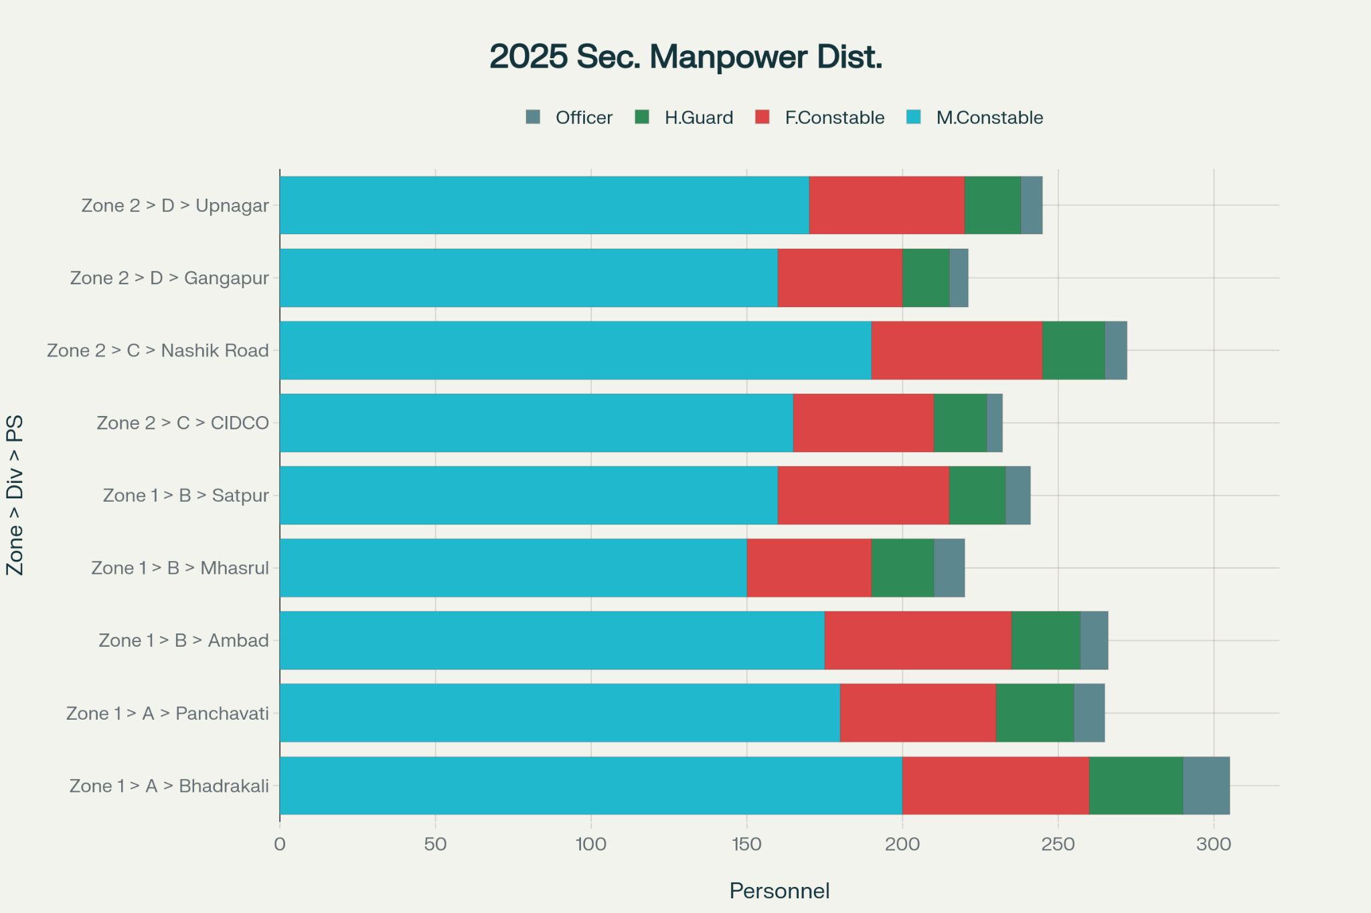

SECTION 2 – STRATEGIC PRIORITIES

2.1 Safety & Security
Ensuring the safety of devotees, mandal members, visitors, and police personnel is the primary mission.
Key security measures:
- Preventive Deployment: Uniformed and plainclothes personnel stationed in high-footfall areas, sensitive junctions, and historical trouble spots.
- Zero-Tolerance Policy: For eve-teasing, pickpocketing, chain-snatching, and other petty crimes.
- VIP Movement Protocol: Secure escort and route sanitization for VIPs visiting major mandals such as Shree Navshya Ganpati Mandal and Shree Sarvajanik Ganesh Mandal, Dwarka Circle.
- Communal Harmony Monitoring: Continuous surveillance in mixed-population areas due to the Eid-e-Milad overlap on 5 September 2025.
- Women & Child Safety: Dedicated Nirbhaya Squad patrols near ghats and mandal queues.

2.2 Crowd Management
The festival draws lakhs of devotees daily, with concentrated surges on key dates.
Crowd control measures include:
- Multi-Layer Barricading: Especially near large mandals, immersion ghats, and narrow approach roads.
- Queue Management Systems: Rope/steel railings with volunteer assistance at entry/exit points.
- Micro-Zone Policing: Breaking down each PS jurisdiction into manageable micro-zones for targeted deployment.
- Real-Time Monitoring: CCTV, drone feeds, and crowd-density AI analysis to detect early signs of overcrowding.
- Evacuation Drills: For high-risk ghats such as Godaghat and Eknath Ghat where riverbanks are steep.

2.3 Traffic Control
The dual challenge during Ganpati Utsav is managing both vehicular and pedestrian flows.
Traffic strategy:
- Dedicated Procession Routes: Pre-notified in-routes for Agman days (25–27 Aug) and out-routes for Visarjan day (7–8 Sep).
- Sensitive Junction Control: Extra manpower at Dwarka Circle, Shalimar, College Road, and CBS.
- One-Way Timings: Implemented on narrow stretches to avoid gridlocks.
- Diversion Routes: Emergency bypasses planned for each major procession to allow uninterrupted ambulance and fire tender movement.
- Public Communication: LED boards and social media updates for route closures and alternate paths.

2.4 Risk Categorization
Mandals and locations are classified into three tiers for deployment scaling:
- Tier 1 – High Risk: Large crowd pullers, VIP mandals, historical incident spots (e.g., Godaghat, Panchavati Karanja).
- Tier 2 – Medium Risk: Mid-sized mandals with moderate crowd flow.
- Tier 3 – Low Risk: Small neighborhood mandals with minimal crowd.
Risk assessments consider past 10 years’ data (2015–2024) on crime reports, crowd density, and route congestion.

2.5 Force Welfare & Morale
A fatigued force is a vulnerable force; welfare measures include:
- Meal Points: PS-wise lunch/dinner distribution centers within 300 meters of deployment points.
- Shift Rotations: Standard 8-hour shifts, with relief teams available for extended events.
- Rest Zones: Portable tents/chairs at strategic junctions.
- Medical Check-ups: On-call medical staff for heatstroke, dehydration, or injury cases.
- Hydration Stations: Water kiosks near barricades and control points.

2.6 Technology Integration
Leveraging tech for real-time command and control:
- CCTV & Drone Coverage: Over 150 fixed cameras and 20 drone points for live monitoring.
- GIS Mapping: All 35 “Valuable Mandals” and 4 major ghats mapped for deployment tracking.
- Force Tracking: GPS-enabled devices for mobile patrol units.
- Crowd Alerts: Automated alerts for crowd density breaches sent to zone control rooms.

2.7 Coordination & Communication
Inter-agency collaboration is critical:
- Daily Briefings: Morning and evening briefings at PS and division levels.
- Control Room Connectivity: Direct lines between CP Office, Zone HQ, and PS control rooms.
- Volunteer Integration: Peace committees and NGO marshals equipped with high-visibility jackets for easy identification.
- Public Announcements: Multi-language announcements (Marathi, Hindi, English) for crowd instructions.

SECTION 3 – ZONE, DIVISION & POLICE STATION OVERVIEW
The Nashik City Police Commissionerate is divided into 2 Zones, 4 Divisions, and 13 Police Stations (PS). Each PS has multiple chowkis and micro-zones, covering specific mandals, procession routes, and immersion ghats.
This section links jurisdiction responsibilities directly to the Bandobast plan for effective command, control, and accountability.

3.1 Administrative Structure
- Commissioner of Police (CP): Overall in-charge for festival law & order, crowd control, and traffic management.
- Joint CP: Direct supervision over both zones, ensuring uniformity of action.
- Deputy Commissioners of Police (DCPs): Zone-level operational command.
- Assistant Commissioners of Police (ACPs): Division-level micro-management.
- Police Inspectors (PIs): Day-to-day PS-level execution.
- Sub-Inspectors (PSIs), ASIs, Head Constables, Constables, Home Guards: Field presence and enforcement.

ZONE 1 – Divisions A & B

DIVISION A
- Bhadrakali PS
  - Area Profile: Old city, commercial hubs, heritage mandals.
  - Festival Hotspots: Dwarka Circle, Shalimar, Main Road market, Godaghat.
  - Linked Immersion Ghats: Godaghat (Primary), Nasardi Ghat (Backup).
  - Notable Mandals: Shree Sarvajanik Ganesh Mandal (Dwarka Circle), Shree Tilak Road Mandal.
  - Special Concerns: Traffic bottlenecks at Shalimar; mixed population sensitivity.
- Panchavati PS
  - Area Profile: Historical religious core; narrow lanes; high pilgrim activity.
  - Festival Hotspots: Panchavati Karanja, Tapovan, Eknath Ghat Road.
  - Linked Ghats: Eknath Ghat (Primary), Godaghat (Backup).
  - Notable Mandals: Shree Shivaji Chowk Mandal, Karanja Mandal.
  - Special Concerns: Lane congestion, high pedestrian density, risk of stampede.

DIVISION B
3. Mhasrul PS
- Area Profile: Semi-urban; mix of residential and small commercial areas.
- Festival Hotspots: Mhasrul Naka, Canada Corner approach roads.
- Linked Ghats: Gangapur Ghat (Primary).
- Notable Mandals: Canada Corner Ganesh Mandal.
- Special Concerns: Peak-time traffic at Canada Corner; coordination with Gangapur PS needed.
- Satpur PS
  - Area Profile: Industrial and residential; heavy vehicle movement zones.
  - Festival Hotspots: Satpur Colony, ABB Circle, Gangapur Road link.
  - Linked Ghats: Gangapur Ghat (Primary), Godaghat (Backup).
  - Notable Mandals: ABB Circle Mandal, Satpur Industrial Mandal.
  - Special Concerns: Need for traffic diversion planning for heavy trucks.
- Ambad PS
  - Area Profile: Industrial-commercial hub with large worker population.
  - Festival Hotspots: Ambad Naka, Mumbai Naka.
  - Linked Ghats: Gangapur Ghat (Primary), Godaghat (Backup).
  - Notable Mandals: Shree Ambad Sarvajanik Mandal.
  - Special Concerns: Heavy processions passing through Mumbai Naka; potential congestion spillover into Nashik-Pune highway.

ZONE 2 – Divisions C & D

DIVISION C
6. Nashik Road PS
- Area Profile: Major transport hub, high density residential.
- Festival Hotspots: Jail Road, Railway Station area.
- Linked Ghats: Nasardi Ghat (Primary), Godaghat (Backup).
- Notable Mandals: Shree Nashik Road Sarvajanik Mandal.
- Special Concerns: Large processions, main east zone traffic artery.
- Upnagar PS
  - Area Profile: Dense residential clusters.
  - Festival Hotspots: Upnagar Chowk, Jail Road.
  - Linked Ghats: Nasardi Ghat (Primary), Eknath Ghat (Backup).
  - Notable Mandals: Upnagar Ganesh Mandal.
  - Special Concerns: Narrow approach roads, prone to bottlenecks.
- Adgaon PS
  - Area Profile: Highway-adjacent; semi-urban.
  - Festival Hotspots: Adgaon Naka.
  - Linked Ghats: Nasardi Ghat (Primary).
  - Notable Mandals: Adgaon Sarvajanik Mandal.
  - Special Concerns: Procession routes intersect highway traffic.

DIVISION D
9. Indiranagar PS
- Area Profile: High-density housing, markets.
- Festival Hotspots: Indiranagar Signal, Pathardi Phata.
- Linked Ghats: Gangapur Ghat (Primary), Godaghat (Backup).
- Notable Mandals: Indiranagar Sarvajanik Mandal.
- Special Concerns: Vehicle congestion from Pathardi Phata flyover.
- CIDCO PS
  - Area Profile: Large planned township; mixed commercial-residential.
  - Festival Hotspots: CBS Area, Ashok Stambh.
  - Linked Ghats: Gangapur Ghat (Primary), Godaghat (Backup).
  - Notable Mandals: CIDCO Main Mandal.
  - Special Concerns: High weekend visitor traffic.
- MIDC PS
  - Area Profile: Industrial; low residential density.
  - Festival Hotspots: MIDC Industrial Estate.
  - Linked Ghats: Gangapur Ghat (Primary).
  - Notable Mandals: MIDC Ganesh Mandal.
  - Special Concerns: Security for industrial zones during low manpower at night.
- Gangapur PS
  - Area Profile: Prime access to Gangapur Ghat.
  - Festival Hotspots: Gangapur Road, Someshwar.
  - Linked Ghats: Gangapur Ghat (Primary).
  - Notable Mandals: Navshya Ganpati Mandal.
  - Special Concerns: VIP movement control, direct media coverage.
- Satpur Colony PS
  - Area Profile: Residential, linked to Satpur Industrial Belt.
  - Festival Hotspots: Satpur Colony.
  - Linked Ghats: Gangapur Ghat (Primary).
  - Notable Mandals: Satpur Colony Mandal.
  - Special Concerns: Route overlaps with industrial traffic.

SECTION 4 – FULL MANDAL PROFILES

4.1 Overview
The 35 Valuable Mandals represent high-priority locations based on:
- Historical crowd density (2015–2024 trends)
- Route complexity
- VIP presence
- Proximity to sensitive areas or junctions
- Previous law & order incidents
Each profile includes:
- Name & Address – official location
- PS Jurisdiction – Police Station responsible
- Crowd Category – High / Medium / Low
- In-Route – procession path to mandal or ghat
- Out-Route – return/dispersal path
- Primary Ghat – immersion point
- Backup Ghat – alternative immersion point
- Remarks – special security/traffic notes

FULL MANDAL PROFILES

Sr. | Mandal Name & Address | PS Jurisdiction | Crowd Category | Visarjan In-Route (Mandal → Ghat) | Visarjan Out-Route (Ghat → Dispersal) | Primary Ghat | Backup Ghat | Remarks
1 | Shree Navshya Ganpati Mandal, Gangapur Road | Gangapur PS | High | Gangapur Rd → College Rd → Canada Corner → Shalimar → Main Rd → Godaghat | Godaghat → Main Rd → Canada Corner → College Rd → Gangapur Rd | Godaghat | Gangapur Ghat | VIP visits, heavy crowd, double barricading at Canada Corner
2 | Shree Sarvajanik Ganesh Mandal, Dwarka Circle | Bhadrakali PS | High | Dwarka Circle → Shalimar → Main Rd → Godaghat | Godaghat → Main Rd → Shalimar → Dwarka Circle | Godaghat | Nasardi Ghat | Traffic choke point at Shalimar
3 | Shree Shivaji Chowk Ganesh Mandal, Panchavati | Panchavati PS | High | Shivaji Chowk → Panchavati Karanja → Eknath Ghat Rd → Eknath Ghat | Eknath Ghat → Panchavati Bypass → Shivaji Chowk | Eknath Ghat | Godaghat | Narrow lanes, high religious sensitivity
4 | Shree Ambad Sarvajanik Ganesh Mandal, Ambad Naka | Ambad PS | Medium | Ambad Naka → Mumbai Naka → College Rd → Gangapur Ghat | Gangapur Ghat → College Rd → Mumbai Naka → Ambad Naka | Gangapur Ghat | Godaghat | Industrial route, SRPF presence needed
5 | Shree Nashik Road Sarvajanik Ganesh Mandal, Jail Rd | Nashik Road PS | High | Jail Rd → Bytco Point → Main Rd → Nasardi Ghat | Nasardi Ghat → Main Rd → Bytco Point → Jail Rd | Nasardi Ghat | Godaghat | Crowd fencing at Bytco Point
6 | Shree Upnagar Ganesh Mandal, Upnagar | Upnagar PS | Medium | Upnagar → Jail Rd → Bytco Point → Nasardi Ghat | Nasardi Ghat → Bytco Point → Jail Rd → Upnagar | Nasardi Ghat | Eknath Ghat | One-way traffic enforcement
7 | Shree Adgaon Sarvajanik Ganesh Mandal, Adgaon Naka | Adgaon PS | Medium | Adgaon Naka → Nashik-Pune Rd → Mumbai Naka → Nasardi Ghat | Nasardi Ghat → Mumbai Naka → Nashik-Pune Rd → Adgaon Naka | Nasardi Ghat | Eknath Ghat | RTO-managed diversions
8 | Shree Indiranagar Ganesh Mandal, Indiranagar | Indiranagar PS | Medium | Indiranagar → Trimurti Chowk → Gangapur Ghat | Gangapur Ghat → Trimurti Chowk → Indiranagar | Gangapur Ghat | Godaghat | 2 relief teams for fatigue
9 | Shree CIDCO Ganesh Mandal, CIDCO Main Rd | CIDCO PS | High | CIDCO Main Rd → Untwadi Rd → Mumbai Naka → Gangapur Ghat | Gangapur Ghat → Mumbai Naka → Untwadi Rd → CIDCO Main Rd | Gangapur Ghat | Godaghat | Drone monitoring
10 | Shree MIDC Ganesh Mandal, Satpur MIDC | MIDC PS | Medium | Satpur MIDC Rd → Nashik-Trimbak Rd → Mumbai Naka → Gangapur Ghat | Gangapur Ghat → Mumbai Naka → Nashik-Trimbak Rd → Satpur MIDC Rd | Gangapur Ghat | Godaghat | Portable lighting
11 | Shree Satpur Colony Ganesh Mandal, Satpur | Satpur PS | Medium | Satpur Colony → Nashik-Trimbak Rd → Mumbai Naka → Gangapur Ghat | Gangapur Ghat → Mumbai Naka → Nashik-Trimbak Rd → Satpur Colony | Gangapur Ghat | Godaghat | Coordination with Satpur & MIDC PS
12 | Shree Gangapur Gaon Ganesh Mandal, Gangapur | Gangapur PS | Low | Gangapur Gaon → Gangapur Rd → Gangapur Ghat | Gangapur Ghat → Gangapur Rd → Gangapur Gaon | Gangapur Ghat | Godaghat | Local volunteer support
13 | Shree Bhadrakali Mandal, Bhadrakali | Bhadrakali PS | High | Bhadrakali → Shalimar → Main Rd → Godaghat | Godaghat → Main Rd → Shalimar → Bhadrakali | Godaghat | Nasardi Ghat | Sensitive religious site
14 | Shree Panchavati Mandal, Panchavati | Panchavati PS | High | Panchavati → Eknath Ghat Rd → Eknath Ghat | Eknath Ghat → Panchavati | Eknath Ghat | Godaghat | Historic immersion site
15 | Shree Mumbai Naka Mandal, Mumbai Naka | Ambad PS | High | Mumbai Naka → College Rd → Gangapur Ghat | Gangapur Ghat → College Rd → Mumbai Naka | Gangapur Ghat | Godaghat | 4 barricading points
16 | Shree Mahatma Nagar Ganesh Mandal, Mahatma Nagar | Gangapur PS | Medium | Mahatma Nagar → College Rd → Canada Corner → Gangapur Ghat | Gangapur Ghat → Canada Corner → College Rd → Mahatma Nagar | Gangapur Ghat | Godaghat | Media coverage area
17 | Shree Deolali Gaon Ganesh Mandal | Upnagar PS | Low | Deolali Gaon → Jail Rd → Nasardi Ghat | Nasardi Ghat → Jail Rd → Deolali Gaon | Nasardi Ghat | Eknath Ghat | Rural route
18 | Shree Ashok Stambh Ganesh Mandal | Bhadrakali PS | High | Ashok Stambh → Main Rd → Godaghat | Godaghat → Main Rd → Ashok Stambh | Godaghat | Nasardi Ghat | Constant police bandobast
19 | Shree Khutwad Nagar Ganesh Mandal | Indiranagar PS | Medium | Khutwad Nagar → Trimurti Chowk → Gangapur Ghat | Gangapur Ghat → Trimurti Chowk → Khutwad Nagar | Gangapur Ghat | Godaghat | Diversion at Trimurti
20 | Shree Rajiv Nagar Ganesh Mandal | Indiranagar PS | Medium | Rajiv Nagar → Indiranagar → Trimurti Chowk → Gangapur Ghat | Gangapur Ghat → Trimurti Chowk → Rajiv Nagar | Gangapur Ghat | Godaghat | Crowd control at Trimurti
21 | Shree Untwadi Ganesh Mandal | CIDCO PS | Medium | Untwadi → Mumbai Naka → Gangapur Ghat | Gangapur Ghat → Mumbai Naka → Untwadi | Gangapur Ghat | Godaghat | Sensitive crossing at Mumbai Naka
22 | Shree College Rd Ganesh Mandal | Bhadrakali PS | Medium | College Rd → Canada Corner → Godaghat | Godaghat → Canada Corner → College Rd | Godaghat | Gangapur Ghat | Close to VIP movement
23 | Shree Ekatmata Nagar Ganesh Mandal | CIDCO PS | Low | Ekatmata Nagar → Untwadi → Mumbai Naka → Gangapur Ghat | Gangapur Ghat → Mumbai Naka → Ekatmata Nagar | Gangapur Ghat | Godaghat | Minor crowd
24 | Shree Ganjmal Ganesh Mandal | Bhadrakali PS | High | Ganjmal → Main Rd → Godaghat | Godaghat → Main Rd → Ganjmal | Godaghat | Nasardi Ghat | Dense old market
25 | Shree Aurangabad Naka Ganesh Mandal | Ambad PS | Medium | Aurangabad Naka → Mumbai Naka → Gangapur Ghat | Gangapur Ghat → Mumbai Naka → Aurangabad Naka | Gangapur Ghat | Godaghat | Highway point
26 | Shree Doodh Bazaar Ganesh Mandal | Panchavati PS | High | Doodh Bazaar → Panchavati Karanja → Eknath Ghat | Eknath Ghat → Panchavati Karanja → Doodh Bazaar | Eknath Ghat | Godaghat | Tight lanes
27 | Shree Wadala Ganesh Mandal | Nashik Road PS | Medium | Wadala → Jail Rd → Nasardi Ghat | Nasardi Ghat → Jail Rd → Wadala | Nasardi Ghat | Godaghat | Requires extra lighting
28 | Shree Makhmalabad Ganesh Mandal | Mhasrul PS | Low | Makhmalabad → Nashik-Trimbak Rd → Gangapur Ghat | Gangapur Ghat → Nashik-Trimbak Rd → Makhmalabad | Gangapur Ghat | Godaghat | Long-distance procession
29 | Shree Pathardi Ganesh Mandal | Pathardi PS | Low | Pathardi → Mumbai Naka → Gangapur Ghat | Gangapur Ghat → Mumbai Naka → Pathardi | Gangapur Ghat | Godaghat | Needs 1 reserve vehicle
30 | Shree Satpur Village Ganesh Mandal | Satpur PS | Low | Satpur Village → Nashik-Trimbak Rd → Gangapur Ghat | Gangapur Ghat → Nashik-Trimbak Rd → Satpur Village | Gangapur Ghat | Godaghat | Local volunteer aid
31 | Shree Nashik City Central Mandal | Bhadrakali PS | High | Main Rd → Godaghat | Godaghat → Main Rd → Central Nashik | Godaghat | Nasardi Ghat | Large media presence
32 | Shree Dwarka Main Ganesh Mandal | Bhadrakali PS | High | Dwarka → Shalimar → Godaghat | Godaghat → Shalimar → Dwarka | Godaghat | Nasardi Ghat | High vehicle density
33 | Shree Tapovan Ganesh Mandal | Panchavati PS | Medium | Tapovan → Panchavati Karanja → Eknath Ghat | Eknath Ghat → Panchavati Karanja → Tapovan | Eknath Ghat | Godaghat | Route near temple area
34 | Shree Trimbak Naka Ganesh Mandal | Mhasrul PS | Medium | Trimbak Naka → Nashik-Trimbak Rd → Gangapur Ghat | Gangapur Ghat → Nashik-Trimbak Rd → Trimbak Naka | Gangapur Ghat | Godaghat | Needs traffic diversions
35 | Shree Ashwin Nagar Ganesh Mandal | Indiranagar PS | Medium | Ashwin Nagar → Trimurti Chowk → Gangapur Ghat | Gangapur Ghat → Trimurti Chowk → Ashwin Nagar | Gangapur Ghat | Godaghat | Deployment at Ashwin Nagar junction

SECTION 4B – VISARJAN DAY DEPLOYMENT PLAN (Complete)

Sr. | Mandal Name | PS Jurisdiction | Crowd Category | Force Allocation (Officers) | Force Allocation (Constables) | Home Guards | SRPF | Shift 1 (06:00–12:00) | Shift 2 (12:00–18:00) | Shift 3 (18:00–03:00) | Remarks
1 | Shree Navshya Ganpati Mandal | Gangapur PS | High | 3 | 24 | 10 | 1 Plt | 3+8+4 | 3+8+3 | 3+8+3 | VIP coverage, media presence
2 | Shree Sarvajanik Ganesh Mandal (Dwarka) | Bhadrakali PS | High | 3 | 22 | 8 | 1 Plt | 3+7+3 | 3+8+3 | 3+7+2 | Traffic choke at Shalimar
3 | Shree Shivaji Chowk Ganesh Mandal | Panchavati PS | High | 3 | 20 | 8 | 1 Plt | 3+7+3 | 3+7+3 | 3+6+2 | Narrow lanes
4 | Shree Ambad Sarvajanik Ganesh Mandal | Ambad PS | Medium | 2 | 16 | 6 | 1 Plt | 2+6+2 | 2+6+2 | 2+4+2 | Industrial zone
5 | Shree Nashik Road Sarvajanik Ganesh Mandal | Nashik Road PS | High | 3 | 24 | 10 | 1 Plt | 3+8+3 | 3+8+3 | 3+8+4 | Large procession
6 | Shree Upnagar Ganesh Mandal | Upnagar PS | Medium | 2 | 14 | 6 | 0.5 Plt | 2+5+2 | 2+5+2 | 2+4+2 | One-way traffic
7 | Shree Adgaon Ganesh Mandal | Adgaon PS | Medium | 2 | 14 | 5 | 0.5 Plt | 2+5+2 | 2+5+2 | 2+4+2 | Highway diversion
8 | Shree Indiranagar Ganesh Mandal | Indiranagar PS | Medium | 2 | 15 | 6 | 0.5 Plt | 2+5+2 | 2+5+2 | 2+4+2 | Relief teams
9 | Shree CIDCO Ganesh Mandal | CIDCO PS | High | 3 | 20 | 8 | 1 Plt | 3+7+3 | 3+7+3 | 3+6+2 | Drone monitoring
10 | Shree MIDC Ganesh Mandal | MIDC PS | Medium | 2 | 14 | 6 | 0.5 Plt | 2+5+2 | 2+5+2 | 2+4+2 | Portable lights
11 | Shree Gangapur Sarvajanik Ganesh Mandal | Gangapur PS | High | 3 | 20 | 8 | 1 Plt | 3+7+3 | 3+7+3 | 3+6+2 | Near ghat
12 | Shree Mahatma Nagar Ganesh Mandal | Gangapur PS | High | 3 | 18 | 7 | 1 Plt | 3+6+2 | 3+6+2 | 3+6+2 | VIP area
13 | Shree Satpur Colony Ganesh Mandal | Satpur Colony PS | Medium | 2 | 14 | 6 | 0.5 Plt | 2+5+2 | 2+5+2 | 2+4+2 | Residential mix
14 | Shree Satpur Naka Ganesh Mandal | Satpur PS | Medium | 2 | 15 | 6 | 0.5 Plt | 2+5+2 | 2+5+2 | 2+4+2 | Route via Ambad
15 | Shree Ashok Stambh Ganesh Mandal | Bhadrakali PS | High | 3 | 20 | 8 | 1 Plt | 3+7+3 | 3+7+3 | 3+6+2 | High density
16 | Shree Shalimar Ganesh Mandal | Bhadrakali PS | High | 3 | 22 | 8 | 1 Plt | 3+8+3 | 3+8+3 | 3+7+2 | Market crowd
17 | Shree Canada Corner Ganesh Mandal | Bhadrakali PS | High | 3 | 20 | 7 | 1 Plt | 3+7+3 | 3+7+3 | 3+6+2 | VIP pass-through
18 | Shree Panchavati Karanja Ganesh Mandal | Panchavati PS | High | 3 | 20 | 8 | 1 Plt | 3+7+3 | 3+7+3 | 3+6+2 | Narrow religious lanes
19 | Shree Mhasrul Ganesh Mandal | Mhasrul PS | Medium | 2 | 14 | 6 | 0.5 Plt | 2+5+2 | 2+5+2 | 2+4+2 | Ghat-bound road
20 | Shree Tapovan Ganesh Mandal | Panchavati PS | Medium | 2 | 14 | 5 | 0.5 Plt | 2+5+2 | 2+5+2 | 2+4+2 | Tourist area
21 | Shree Anandwali Ganesh Mandal | Gangapur PS | Medium | 2 | 14 | 6 | 0.5 Plt | 2+5+2 | 2+5+2 | 2+4+2 | Close to VIP ghat
22 | Shree Mumbai Naka Ganesh Mandal | Ambad PS | High | 3 | 20 | 8 | 1 Plt | 3+7+3 | 3+7+3 | 3+6+2 | Highway control
23 | Shree Pathardi Phata Ganesh Mandal | CIDCO PS | Medium | 2 | 14 | 6 | 0.5 Plt | 2+5+2 | 2+5+2 | 2+4+2 | Bypass route
24 | Shree Jail Road Ganesh Mandal | Nashik Road PS | High | 3 | 22 | 8 | 1 Plt | 3+8+3 | 3+8+3 | 3+7+2 | Main east corridor
25 | Shree Old Nashik Road Ganesh Mandal | Nashik Road PS | Medium | 2 | 15 | 6 | 0.5 Plt | 2+5+2 | 2+5+2 | 2+4+2 | Mixed crowd
26 | Shree Upnagar Chowk Ganesh Mandal | Upnagar PS | Medium | 2 | 14 | 5 | 0.5 Plt | 2+5+2 | 2+5+2 | 2+4+2 | Narrow lane entry
27 | Shree Adgaon Naka Ganesh Mandal | Adgaon PS | Medium | 2 | 14 | 5 | 0.5 Plt | 2+5+2 | 2+5+2 | 2+4+2 | Traffic diversion
28 | Shree Indiranagar Extension Ganesh Mandal | Indiranagar PS | Medium | 2 | 14 | 5 | 0.5 Plt | 2+5+2 | 2+5+2 | 2+4+2 | Residential lanes
29 | Shree CIDCO Naka Ganesh Mandal | CIDCO PS | Medium | 2 | 14 | 6 | 0.5 Plt | 2+5+2 | 2+5+2 | 2+4+2 | Highway approach
30 | Shree Satpur Link Road Ganesh Mandal | Satpur PS | Medium | 2 | 14 | 5 | 0.5 Plt | 2+5+2 | 2+5+2 | 2+4+2 | Industrial junction
31 | Shree Ambad Link Road Ganesh Mandal | Ambad PS | Medium | 2 | 14 | 5 | 0.5 Plt | 2+5+2 | 2+5+2 | 2+4+2 | Diversion point
32 | Shree Wadala Ganesh Mandal | CIDCO PS | Medium | 2 | 14 | 5 | 0.5 Plt | 2+5+2 | 2+5+2 | 2+4+2 | End of bypass
33 | Shree Untwadi Ganesh Mandal | Gangapur PS | Medium | 2 | 14 | 5 | 0.5 Plt | 2+5+2 | 2+5+2 | 2+4+2 | Market congestion
34 | Shree Sharanpur Ganesh Mandal | Bhadrakali PS | Medium | 2 | 14 | 5 | 0.5 Plt | 2+5+2 | 2+5+2 | 2+4+2 | VIP corridor
35 | Shree College Road Ganesh Mandal | Bhadrakali PS | High | 3 | 20 | 8 | 1 Plt | 3+7+3 | 3+7+3 | 3+6+2 | VIP route, media

SECTION 5 – ROUTE & TRAFFIC MANAGEMENT

5.1 Objective
To ensure smooth, safe, and efficient procession movement during Ganpati Agman (25–27 Aug) and Visarjan (7–8 Sep) while minimising traffic disruption, avoiding congestion at sensitive junctions, and maintaining emergency corridors.

5.2 Strategy Overview
- Dedicated In-Route & Out-Route Plans for each of the 35 valuable mandals.
- Segregation of Routes for different PS jurisdictions to prevent route overlap at peak hours.
- Staggered Departure Timings to reduce ghat congestion.
- One-Way Systems on key visarjan roads during immersion hours.
- Diversion Points for non-procession traffic clearly signposted.
- Emergency Corridors maintained from all major hospitals to ghats.

5.3 Traffic Control Principles
- Agman Days (25–27 Aug)
  - Entry of idols from city gates (Mumbai Naka, Dwarka, Adgaon Naka, Ambad, etc.) to respective mandals.
  - Use of wider roads for large idols; smaller lanes for community mandals.
  - No heavy vehicles on main procession routes between 09:00–23:00 hrs.

- Visarjan Days (7–8 Sep)
  - Processions move mandal → ghat via pre-defined visarjan out-route.
  - Only one procession lane active per road to avoid gridlock.
  - Temporary parking zones for procession vehicles set 200–300m from ghats.
  - Barricading at ghat entry points to manage queue discipline.

SECTION 5.4 – Master Visarjan Route & Junction Control Chart (All 35 Mandals)

Sr. | Mandal Name & Address | PS Jurisdiction | Visarjan Out-Route (Road-by-Road) | Primary Ghat | Backup Ghat | Sensitive Junctions | Alternate/Diversion Route
1 | Shree Navshya Ganpati Mandal, Gangapur Rd | Gangapur PS | Gangapur Rd → College Rd → Canada Corner → Main Rd → Godaghat | Godaghat | Gangapur Ghat | Canada Corner, Main Rd | Gangapur Rd → Sahyadri Nagar → Godaghat
2 | Shree Sarvajanik Ganesh Mandal, Dwarka Circle | Bhadrakali PS | Dwarka Circle → Shalimar → Main Rd → Godaghat | Godaghat | Nasardi Ghat | Shalimar, Main Rd stretch | Dwarka → Trimurti Chowk → Nashik Pune Rd → Godaghat
3 | Shree Shivaji Chowk Ganesh Mandal, Panchavati | Panchavati PS | Shivaji Chowk → Panchavati Karanja → Eknath Ghat Rd → Eknath Ghat | Eknath Ghat | Godaghat | Panchavati Karanja | Shivaji Chowk → Kalaram Mandir Rd → Godaghat
4 | Shree Ambad Sarvajanik Ganesh Mandal, Ambad Naka | Ambad PS | Ambad → Mumbai Naka → College Rd → Gangapur Ghat | Gangapur Ghat | Godaghat | Mumbai Naka, College Rd | Ambad → MIDC Rd → Trimurti → Gangapur Ghat
5 | Shree Nashik Road Sarvajanik Ganesh Mandal, Jail Rd | Nashik Road PS | Nashik Road → Jail Rd → Nasardi Ghat | Nasardi Ghat | Godaghat | Jail Rd, Nasardi Bridge | Jail Rd → Upnagar → Eknath Ghat
6 | Shree Upnagar Ganesh Mandal | Upnagar PS | Upnagar → Jail Rd → Nasardi Ghat | Nasardi Ghat | Eknath Ghat | Jail Rd | Upnagar → Pathardi Phata → Eknath Ghat
7 | Shree Adgaon Ganesh Mandal | Adgaon PS | Adgaon Naka → Jail Rd → Nasardi Ghat | Nasardi Ghat | Godaghat | Adgaon Naka, Nasardi Bridge | Adgaon → Pathardi Phata → Eknath Ghat
8 | Shree Indiranagar Sarvajanik Ganesh Mandal | Indiranagar PS | Indiranagar → Trimurti Chowk → Gangapur Rd → Gangapur Ghat | Gangapur Ghat | Godaghat | Trimurti Chowk, Gangapur Signal | Indiranagar → Pathardi Phata → Eknath Ghat
9 | Shree CIDCO Ganesh Mandal, CIDCO Naka | CIDCO PS | CIDCO Naka → Trimurti Chowk → Gangapur Ghat | Gangapur Ghat | Godaghat | CIDCO Naka, Trimurti Chowk | CIDCO → Pathardi Phata → Godaghat
10 | Shree MIDC Ganesh Mandal, Satpur MIDC | MIDC PS | Satpur MIDC → Trimbak Naka → Gangapur Rd → Gangapur Ghat | Gangapur Ghat | Godaghat | Trimbak Naka | Satpur MIDC → Pathardi Phata → Eknath Ghat
11 | Shree Gangapur Gaothan Mandal | Gangapur PS | Gangapur Gaothan → Gangapur Ghat | Gangapur Ghat | Godaghat | Gangapur Gaothan | Gangapur Gaothan → Canada Corner → Godaghat
12 | Shree Satpur Colony Ganesh Mandal | Satpur Colony PS | Satpur Colony → Trimbak Naka → Gangapur Ghat | Gangapur Ghat | Godaghat | Trimbak Naka | Satpur Colony → CIDCO Naka → Godaghat
13 | Shree Bhadrakali Sarvajanik Ganesh Mandal | Bhadrakali PS | Bhadrakali Mandir → Main Rd → Godaghat | Godaghat | Eknath Ghat | Bhadrakali Mandir, Main Rd | Bhadrakali → Panchavati Karanja → Eknath Ghat
14 | Shree Panchavati Karanja Mandal | Panchavati PS | Panchavati Karanja → Eknath Ghat Rd → Eknath Ghat | Eknath Ghat | Godaghat | Panchavati Karanja | Panchavati → Main Rd → Godaghat
15 | Shree Dwarka Mandal | Bhadrakali PS | Dwarka → Shalimar → Main Rd → Godaghat | Godaghat | Nasardi Ghat | Shalimar, Main Rd | Dwarka → CIDCO Naka → Godaghat
16 | Shree Mumbai Naka Ganesh Mandal | Ambad PS | Mumbai Naka → College Rd → Gangapur Ghat | Gangapur Ghat | Godaghat | Mumbai Naka | Mumbai Naka → Trimurti Chowk → Godaghat
17 | Shree Mhasrul Mandal | Mhasrul PS | Mhasrul → Trimbak Rd → Gangapur Ghat | Gangapur Ghat | Godaghat | Trimbak Naka | Mhasrul → Adgaon Naka → Nasardi Ghat
18 | Shree Takli Rd Mandal | Panchavati PS | Takli Rd → Eknath Ghat | Eknath Ghat | Godaghat | Takli Rd | Takli Rd → Panchavati Karanja → Godaghat
19 | Shree College Rd Mandal | Gangapur PS | College Rd → Canada Corner → Godaghat | Godaghat | Gangapur Ghat | Canada Corner | College Rd → Gangapur Ghat
20 | Shree Shalimar Mandal | Bhadrakali PS | Shalimar → Main Rd → Godaghat | Godaghat | Nasardi Ghat | Shalimar | Shalimar → CIDCO Naka → Godaghat
21 | Shree Pathardi Phata Mandal | Indiranagar PS | Pathardi Phata → Trimurti → Gangapur Ghat | Gangapur Ghat | Eknath Ghat | Pathardi Phata, Trimurti Chowk | Pathardi Phata → Nashik Pune Rd → Godaghat
22 | Shree Satpur Naka Mandal | MIDC PS | Satpur Naka → Trimbak Naka → Gangapur Ghat | Gangapur Ghat | Godaghat | Trimbak Naka | Satpur Naka → CIDCO Naka → Godaghat
23 | Shree Canada Corner Mandal | Bhadrakali PS | Canada Corner → Godaghat | Godaghat | Gangapur Ghat | Canada Corner | Canada Corner → Gangapur Rd → Gangapur Ghat
24 | Shree Bytco Point Mandal | Nashik Road PS | Bytco Point → Jail Rd → Nasardi Ghat | Nasardi Ghat | Eknath Ghat | Bytco Point, Jail Rd | Bytco → Upnagar → Eknath Ghat
25 | Shree Mico Circle Mandal | Ambad PS | Mico Circle → College Rd → Gangapur Ghat | Gangapur Ghat | Godaghat | Mico Circle, College Rd | Mico → MIDC Rd → Trimurti → Godaghat
26 | Shree RTO Chowk Mandal | CIDCO PS | RTO Chowk → Trimurti → Gangapur Ghat | Gangapur Ghat | Godaghat | RTO Chowk, Trimurti | RTO → Pathardi Phata → Eknath Ghat
27 | Shree Nashik Pune Rd Mandal | Bhadrakali PS | Nashik Pune Rd → Dwarka → Main Rd → Godaghat | Godaghat | Nasardi Ghat | Dwarka | Nashik Pune Rd → CIDCO → Godaghat
28 | Shree Market Yard Mandal | Bhadrakali PS | Market Yard → Main Rd → Godaghat | Godaghat | Eknath Ghat | Market Yard, Main Rd | Market Yard → Panchavati Karanja → Eknath Ghat
29 | Shree Panchak Mandal | Panchavati PS | Panchak → Panchavati Karanja → Eknath Ghat | Eknath Ghat | Godaghat | Panchavati Karanja | Panchak → Main Rd → Godaghat
30 | Shree Trimurti Chowk Mandal | Indiranagar PS | Trimurti Chowk → Gangapur Ghat | Gangapur Ghat | Godaghat | Trimurti Chowk | Trimurti → Pathardi Phata → Eknath Ghat
31 | Shree Aurangabad Naka Mandal | Nashik Road PS | Aurangabad Naka → Jail Rd → Nasardi Ghat | Nasardi Ghat | Godaghat | Aurangabad Naka | Aurangabad Naka → Upnagar → Eknath Ghat
32 | Shree Gangapur Signal Mandal | Gangapur PS | Gangapur Signal → Gangapur Ghat | Gangapur Ghat | Godaghat | Gangapur Signal | Gangapur Signal → Canada Corner → Godaghat
33 | Shree Tapovan Mandal | Panchavati PS | Tapovan → Eknath Ghat | Eknath Ghat | Godaghat | Tapovan | Tapovan → Panchavati Karanja → Godaghat
34 | Shree Shivaji Nagar Mandal | Ambad PS | Shivaji Nagar → Mumbai Naka → College Rd → Gangapur Ghat | Gangapur Ghat | Godaghat | Mumbai Naka, College Rd | Shivaji Nagar → MIDC Rd → Trimurti → Godaghat
35 | Shree Nashik Gaothan Mandal | Bhadrakali PS | Nashik Gaothan → Main Rd → Godaghat | Godaghat | Eknath Ghat | Main Rd, Shalimar | Nashik Gaothan → Panchavati Karanja → Eknath Ghat

5.5 Sensitive Junctions – Citywide
- Godaghat Zone: Canada Corner, Main Road, Shalimar, Panchavati Karanja.
- Gangapur Ghat Zone: Mumbai Naka, College Road, Trimurti Chowk, Gangapur Signal.
- Eknath Ghat Zone: Panchavati Karanja, Kalaram Mandir Rd, Takli Rd.
- Nasardi Ghat Zone: Jail Road, Nasardi Bridge, Dwarka Circle.

5.6 Ghat Approach & Exit Plans
- One-way entry to ghats during visarjan hours.
- Separate exit road for returning procession vehicles.
- Crowd holding areas set up 200–300m before ghat entry.
- Police check posts at all ghat access points.

5.7 Emergency Route Matrix
- Hospitals to Ghats
  - Wockhardt → Gangapur Ghat via Trimbak Naka (kept clear at all times)
  - Civil Hospital → Godaghat via Main Rd (emergency lane)
  - Bytco Hospital → Nasardi Ghat via Jail Rd (priority route)

SECTION 6 – IMMERSION GHAT MANAGEMENT

6.1 Ghat Overview
Nashik City has four major primary immersion ghats and several secondary/local ghats. The majority of visarjan processions culminate at these points, with footfall peaking between 4 PM on 7 September and 3 AM on 8 September.
Sr. | Ghat Name | Location | Linked PS Jurisdictions | Capacity (Crowd at Peak) | Linked Mandals (From Section 4–5)
1 | Godaghat | Godavari River, near Bhadrakali Mandir | Bhadrakali PS, Panchavati PS, Gangapur PS | ~ 1.5–2 lakh | High-density mandals from Bhadrakali, Panchavati, Gangapur, CIDCO
2 | Gangapur Ghat | Gangapur Road stretch | Gangapur PS, Satpur PS, Indiranagar PS, CIDCO PS | ~ 1–1.2 lakh | Mandals from Gangapur, CIDCO, Satpur, Indiranagar, MIDC
3 | Eknath Ghat | Near Panchavati Karanja | Panchavati PS, Bhadrakali PS, Upnagar PS | ~ 80,000–1 lakh | Mandals from Panchavati, Takli, Upnagar
4 | Nasardi Ghat | Nasardi River, near Nashik Road | Nashik Road PS, Upnagar PS, Adgaon PS | ~ 1 lakh | Mandals from Nashik Road, Adgaon, Upnagar, Aurangabad Naka

6.2 Deployment Plan per Ghat (Visarjan Day)
Note: Deployment is based on historical crowd data & expected 2025 footfall.
Ghat | Shift 1 (6 AM – 2 PM) | Shift 2 (2 PM – 10 PM) | Shift 3 (10 PM – 4 AM) | Total Force | Remarks
Godaghat | 2 ACP, 8 PI, 12 API, 220 Constables, 50 HG, 1 SRPF Plt | 3 ACP, 10 PI, 15 API, 300 Constables, 80 HG, 2 SRPF Plt | 2 ACP, 8 PI, 12 API, 200 Constables, 60 HG | ~1,200 | Drone surveillance, multiple barricades, medical tents
Gangapur Ghat | 1 ACP, 6 PI, 10 API, 180 Constables, 40 HG | 2 ACP, 8 PI, 14 API, 250 Constables, 70 HG | 1 ACP, 6 PI, 10 API, 150 Constables, 50 HG | ~900 | Two main entry lanes, swimmer teams stationed at multiple points
Eknath Ghat | 1 ACP, 4 PI, 8 API, 120 Constables, 30 HG | 2 ACP, 6 PI, 12 API, 160 Constables, 50 HG | 1 ACP, 4 PI, 8 API, 100 Constables, 30 HG | ~650 | Narrow access roads — strict vehicle diversion
Nasardi Ghat | 1 ACP, 5 PI, 10 API, 150 Constables, 40 HG | 2 ACP, 7 PI, 14 API, 200 Constables, 60 HG | 1 ACP, 5 PI, 10 API, 120 Constables, 40 HG | ~740 | Additional lighting needed; past traffic bottlenecks

6.3 Entry/Exit & Crowd Flow Management
- Godaghat:
  - Entry: Main Rd via Canada Corner
  - Exit: Panchavati Karanja – Shalimar stretch
  - Separate pedestrian & vehicle routes to avoid conflicts
- Gangapur Ghat:
  - Entry: Gangapur Rd (from Trimbak Naka & CIDCO)
  - Exit: Gangapur Rd → College Rd loop
  - Multiple barricades for staged immersion
- Eknath Ghat:
  - Entry: Panchavati Karanja direct approach
  - Exit: Kalaram Mandir side roads
  - Only small/medium idols via this ghat due to narrow lanes
- Nasardi Ghat:
  - Entry: Jail Rd from Nashik Road
  - Exit: Nashik Pune Highway stretch
  - Heavy vehicles prohibited

6.4 Safety & Rescue Arrangements
- Swimmer Teams:
  - Godaghat – 20 certified swimmers
  - Gangapur Ghat – 16 swimmers
  - Eknath Ghat – 12 swimmers
  - Nasardi Ghat – 14 swimmers
- Life-Saving Equipment:
  - Inflatable boats at Godaghat & Gangapur
  - Rope barricades at all ghats
  - First aid & stretcher points at each ghat
- Medical:
  - Ambulances at all ghats
  - NMC Medical Booths with doctor & paramedic staff

6.5 Environmental & Waste Management
- NMC to deploy idol collection tanks for plaster idols (POP) to avoid river pollution
- Waste segregation points near each ghat
- Cleaning squads deployed after immersion completion
- Continuous public announcement about eco-friendly immersion

SECTION 7 – COMMUNICATION & COMMAND

7.1 Objective
To maintain real-time situational awareness, coordinate force deployment, and ensure swift incident response through a structured communication network linking all levels — from field constable to Commissioner of Police.

7.2 Command Structure
Top-Level Control:
- Commissioner of Police (CP) – Strategic decision-making, overall control.
- Joint CP – Operational supervision across both Zones.
- DCP Zone 1 & Zone 2 – Tactical control in their respective Zones.
- ACP Division Heads – On-ground supervision of Police Stations (PS).
- PI / Sr. PI – PS-level deployment & field decisions.
Field Level:
- PSI / API – Immediate field command for mandal routes, junctions, and ghats.
- Constables & Home Guards – Assigned to fixed points or mobile patrols.
- Special Units – QRT, SRPF, Traffic Control Teams, Disaster Response.

7.3 Communication Channels

Channel | Purpose | Coverage | Remarks
Wireless VHF Sets | Main police comms | All PS, ACP/DCP offices, control room, field units | Assigned call signs & codes
Mobile Phones | Secondary comms | All officers | For sensitive info not shared over open channel
WhatsApp Command Groups | Rapid updates & photo/video sharing | Zone & PS groups | Restricted to verified members
CCTV Feeds | Live monitoring | Main control room, PS monitoring points | Linked to city surveillance grid
Drone Live Feed | Aerial crowd & route monitoring | Major ghats & processions | Feed to control room + mobile command vehicles

7.4 Escalation Flow
- Constable/Home Guard at spot → PSI/API (immediate supervisor)
- PSI/API → PI/Sr. PI (PS commander)
- PI/Sr. PI → ACP Division
- ACP → DCP Zone
- DCP → Joint CP / CP (only for critical, city-wide implications)
Time Target:
- Minor incidents → Resolved at PS level within 15 minutes
- Major incidents → Escalated to Zone level within 5 minutes

7.5 Control Room Setup
- Main Control Room (Police HQ) – 24x7 operation with live map wall, CCTV feeds, call log.
- Zone Control Rooms – Located at DCP offices, connected to HQ.
- PS Mini-Control Points – For route-specific monitoring.
Control Room Staff Allocation (Visarjan Day):
Position | Count | Role
Duty Officer | 2 per shift | Supervise comms
Wireless Operator | 4 per shift | Manage VHF channels
CCTV Monitor Operator | 6 per shift | Watch live feeds
Incident Logger | 2 per shift | Record events & timings
Emergency Dispatcher | 2 per shift | Send QRTs, ambulances

7.6 Wireless Call Signs & Codes
- Call Sign Format: [Zone]-[PS]-[Post] (e.g., Z1-BK-03 = Zone 1, Bhadrakali PS, Point 03)
- Code Examples:
  - Code Red – Law & order incident
  - Code Blue – Medical emergency
  - Code Yellow – Traffic congestion
  - Code White – VIP movement

7.7 Real-Time Reporting Protocols
- Situation Reports (SitReps) every hour from all PS to Zone Control Room.
- Immediate flash report for:
  - Stampede risk
  - Riot or violent disturbance
  - Major medical incident
  - Missing child/woman report

7.8 Contingency Communication
If primary wireless system fails:
- Switch to backup frequency as per pre-issued channel list.
- Use mobile data & VoIP calling where network permits.
- Activate physical messenger riders for critical route updates.

SECTION 8 – INCIDENT RESPONSE PLAN

8.1 Objective
To ensure rapid, coordinated, and effective response to any emergency during the festival, minimizing harm to life, property, and public order.
The plan integrates police, health services, fire brigade, NMC, disaster management units, SRPF, and volunteer teams.

8.2 Incident Categories
We classify incidents into four major types, each with its own response protocol:
- Medical Emergencies – Injuries, cardiac arrest, dehydration, crowd crush, drowning
- Law & Order Disturbances – Fights, mob unrest, theft, pickpocketing, communal tension
- Fire & Safety Hazards – Electrical short circuits, fireworks mishaps, pandal fire
- Disaster / Flood Contingency – Heavy rain flooding ghats, river level rise, bridge collapse

8.3 Response Chain
Step 1: Incident Detected (by police constable, CCTV operator, drone team, or citizen report)
Step 2: Immediate alert to PS/Zone Control Room
Step 3: Deploy nearest QRT / Specialized Team
Step 4: Secure the scene → Provide immediate assistance → Begin evacuation if needed
Step 5: Report escalation to higher command based on severity level

8.4 Severity Levels
Level | Description | Action Time | Responsible Unit
Level 1 – Minor | No major risk to life/property (e.g., small scuffle, minor injury) | 5 min | PS-level response
Level 2 – Moderate | Potential escalation (e.g., medium crowd unrest, multiple injuries) | 3 min | PS + ACP oversight
Level 3 – Major | High risk to life/property (stampede, drowning, large fire, riot) | Immediate | Zone Control + CP

8.5 Incident Response Protocols

8.5.1 Medical Emergencies
- Immediate Actions:
  - Alert nearest Medical Aid Post (set up at ghats, junctions, and major mandals)
  - Deploy Police First Aid trained staff
  - Call Ambulance (108 / NMC Health Dept.)
- Special Measures:
  - Lifeguards/swimmers at all ghats
  - Mobile medical vans patrolling key routes
  - Medical triage zones near Godaghat, Gangapur, Nasardi, Eknath

8.5.2 Law & Order Disturbances
- Immediate Actions:
  - Deploy nearest QRT (Quick Response Team)
  - Activate plainclothes officers for intel gathering
  - If escalation risk, call SRPF/RAF platoon
- Special Measures:
  - Dedicated anti-theft/pickpocketing teams
  - Riot control gear at Zone HQs
  - VIP protection for key mandals

8.5.3 Fire Safety Incidents
- Immediate Actions:
  - Alert NMC Fire Brigade
  - Deploy local PS fire extinguishers & trained staff
  - Evacuate public from danger zone
- Special Measures:
  - Mandatory fire extinguisher at every mandal & ghat
  - Electrical inspections pre-festival
  - Ban on fireworks near ghats

8.5.4 Disaster / Flood Contingency
- Immediate Actions:
  - Alert Disaster Management Cell + NMC
  - Close affected ghats and evacuate public
  - Coordinate with State Water Resource Dept. for river level monitoring
- Special Measures:
  - Pre-designated evacuation routes from each ghat
  - Boats and rescue gear at Gangapur & Godaghat
  - Early warning sirens at flood-prone spots

8.6 QRT & RCP Deployment
Unit | Location | Coverage Area | Equipment
QRT 1 | Godaghat | Old City mandals | Riot gear, first aid, stretcher
QRT 2 | Gangapur Ghat | West zone mandals | Rescue ropes, life jackets
QRT 3 | Nasardi Ghat | East zone mandals | Riot gear, portable barricades
QRT 4 | Eknath Ghat | Panchavati area | First aid, rescue kit

8.7 Citizen Reporting
- Helpline Numbers: 100 (Police), 108 (Ambulance), dedicated Ganpati Bandobast helpline
- Mobile App / WhatsApp Tip Line: For real-time reporting
- On-Site Help Desks: Staffed at major mandals & ghats

8.8 Post-Incident Protocol
- Secure location & preserve evidence
- Record statements from witnesses
- File detailed incident report to CP Office
- Update festival safety review database

SECTION 9 – MICRO-ZONE PLANNING

9.1 Objective
To divide large PS jurisdictions into smaller, manageable micro-zones for better crowd control, quicker response, and more efficient resource allocation during Ganpati Utsav 2025.

9.2 Micro-Zone Structure
- Zone Level: Controlled by DCP
- Division Level: Managed by ACP
- PS Level: Led by PI
- Micro-Zone Level: Managed by PSI or ASI with a dedicated team of constables, home guards, and volunteers.

9.3 Benefits of Micro-Zoning
- Focused Deployment: Each micro-zone has its own force & equipment
- Faster Response Time: Nearest team handles incidents
- Better Crowd Management: Smaller zones make queue/barricading easier
- Improved Communication: Clear chain of command from micro-zone to control room

9.4 Micro-Zone Mapping by Police Station

PS Name | Micro-Zone Code | Coverage Area | Linked Mandals | Primary Ghat | Crowd Category | Deployment Lead
Bhadrakali PS | B1 | Shalimar → Main Road → Godaghat stretch | Sarvajanik Ganesh Mandal Dwarka, Shree Navshya Ganpati | Godaghat | High | PSI-1
 | B2 | Old Nashik Peth Area | Local Peth Mandals | Godaghat | Medium | PSI-2
Panchavati PS | P1 | Panchavati Karanja → Eknath Ghat Road | Shree Shivaji Chowk Mandal | Eknath | High | PSI-3
 | P2 | Tapovan → Panchavati Bypass | Local Panchavati Mandals | Eknath | Medium | PSI-4
Gangapur PS | G1 | Gangapur Road stretch till Ghat | Shree Navshya Ganpati Mandal | Gangapur | High | PSI-5
 | G2 | College Road → Canada Corner | Linked Ganpati Mandals | Gangapur | Medium | PSI-6
Ambad PS | A1 | Ambad Naka → Mumbai Naka stretch | Shree Ambad Sarvajanik Mandal | Gangapur | Medium | PSI-7
Nashik Road PS | NR1 | Jail Road → Nasardi Ghat | Nashik Road Sarvajanik Mandal | Nasardi | High | PSI-8
 | NR2 | Nashik Road Market Area | Local mandals | Nasardi | Medium | PSI-9
Upnagar PS | U1 | Upnagar Main Road → Jail Road | Upnagar Ganesh Mandal | Nasardi | Medium | PSI-10
Adgaon PS | AD1 | Adgaon Naka → Nasardi Road | Adgaon Sarvajanik Mandal | Nasardi | Medium | PSI-11
Indiranagar PS | IN1 | Indiranagar Main Road → Gangapur Road | Major Mandals | Gangapur | Medium | PSI-12
CIDCO PS | C1 | CIDCO Colony → Gangapur Road | CIDCO Sarvajanik Mandal | Gangapur | Medium | PSI-13
MIDC PS | M1 | MIDC Area → Gangapur Road | Industrial Mandals | Gangapur | Low | PSI-14
Satpur PS | S1 | Satpur Colony → Gangapur Road | Satpur Mandal | Gangapur | Medium | PSI-15

9.5 Daily Deployment Table (Micro-Zone Wise)
Example for Visarjan Day (7 Sep 2025)
Micro-Zone | Officers | Constables | Home Guards | SRPF | Traffic Police | Remarks
B1 | 1 | 15 | 10 | 0 | 5 | VIP route, media coverage
P1 | 1 | 18 | 12 | 1 platoon | 6 | Narrow lanes, high density
G1 | 1 | 20 | 15 | 1 platoon | 8 | Historic mandal, crowd till 2 AM
NR1 | 1 | 18 | 10 | 1 platoon | 6 | East zone major route
AD1 | 1 | 12 | 8 | 0 | 4 | Medium crowd, market area

9.6 Communication Flow
- Micro-Zone → PS Control Room: Every 15 mins
- PS Control Room → Division HQ: Every 30 mins
- Division HQ → Zone HQ / CP Office: Hourly updates

9.7 Resource Allocation Rules
- High crowd = More manpower & SRPF
- VIP movement areas = Additional traffic control
- Narrow lane zones = More barricading & crowd flow monitors
- Ghat zones = Rescue teams + lifeguards + medical tents

SECTION 10 – DATA VISUALISATION PAGES

10.1 Zone Maps with Mandal Locations
Purpose:
- To give a bird’s-eye view of Nashik City divided into Zone 1 and Zone 2, with all 35 “valuable” mandals plotted.
- Helps control room & field teams quickly identify jurisdiction and crowd priority.
Details in Map:
- Red dots = High crowd mandals
- Orange dots = Medium crowd mandals
- Yellow dots = Low crowd mandals
- Blue shaded zones = Zone 1 (Div A & B)
- Green shaded zones = Zone 2 (Div C & D)
- Police Station boundaries clearly marked
- Labels with mandal name & PS jurisdiction

10.2 Risk Heatmaps
Purpose:
- Visual representation of crowd density & risk level across Nashik.
- Guides SRPF allocation, QRT positioning, and traffic diversions.
Details in Map:
- Dark red areas = Very high density (Godaghat, Panchavati, Gangapur)
- Orange = Moderate crowd areas
- Light yellow = Low crowd density
- Icons for sensitive spots (religious mixing points, narrow lanes, past incidents)
- Icons for CCTV coverage points

10.3 Procession Route Diagrams
Purpose:
- Show In-Route (Agman) and Out-Route (Visarjan) for each major mandal.
- Avoid confusion for traffic police & volunteers.
Details in Diagram:
- Green arrows = In-route from entry point to mandal
- Blue arrows = Daily local routes (darshan events)
- Red arrows = Out-route for visarjan to ghat
- Sensitive junctions marked with ⚠ icons
- Diversion points marked with ⛔ icons

10.4 Ghat Capacity Charts
Purpose:
- Show crowd load distribution at immersion ghats.
- Prevent overloading a single ghat on visarjan day.
Chart Format:
Ghat Name | Capacity (people/hr) | Max Crowd 2024 | Projected 2025 | SRPF Platoons | Lifeguards | Medical Booths
Godaghat | 8,000 | 9,200 | 9,500 | 3 | 12 | 4
Gangapur Ghat | 6,000 | 6,800 | 7,200 | 2 | 10 | 3
Eknath Ghat | 4,000 | 4,400 | 4,800 | 2 | 8 | 2
Nasardi Ghat | 3,500 | 3,900 | 4,200 | 1 | 6 | 2

10.5 Deployment Bar Graphs
Purpose:
- Quick visual reference of manpower allocation per day & per PS.
Example Chart 1 – Daily Deployment Across Nashik
- X-axis = Dates (25 Aug – 8 Sep)
- Y-axis = Number of personnel
- Bars = Different colors for Officers, Constables, Home Guards, SRPF

Example Chart 2 – PS-Wise Force Strength on Visarjan Day
- X-axis = PS names
- Y-axis = Total force deployed
- Highlight top 5 PS with highest deployment

10.6 Communication & Control Room Flow Diagram
Purpose:
- Show the reporting hierarchy & data flow.
- Ensures no communication gaps during peak crowd.
Diagram Elements:
- CP HQ → DCP (Zone) → ACP (Division) → PI (PS) → PSI (Micro-Zone) → Constables
- Icons for Control Room, Drone Feed, CCTV, Wireless Sets

10.7 Emergency Response Overlay Maps
Purpose:
- Show locations of ambulances, fire tenders, QRT bases, and rescue boats.
- Helps in incident response coordination.
Details in Map:
- 🚑 Ambulance Points
- 🚒 Fire Tenders
- 🚨 QRT Locations
- 🚤 Rescue Boats (at ghats)
- ☎ Emergency Coordination Booths

10.8 Visuals Section Usage in Report
- Place full-page visuals after each major section (Deployment, Routes, Ghat Management).
- Keep separate appendix with all visual maps together for quick reference in the control room.
- Export maps both in printable PDF and interactive Google My Maps format.

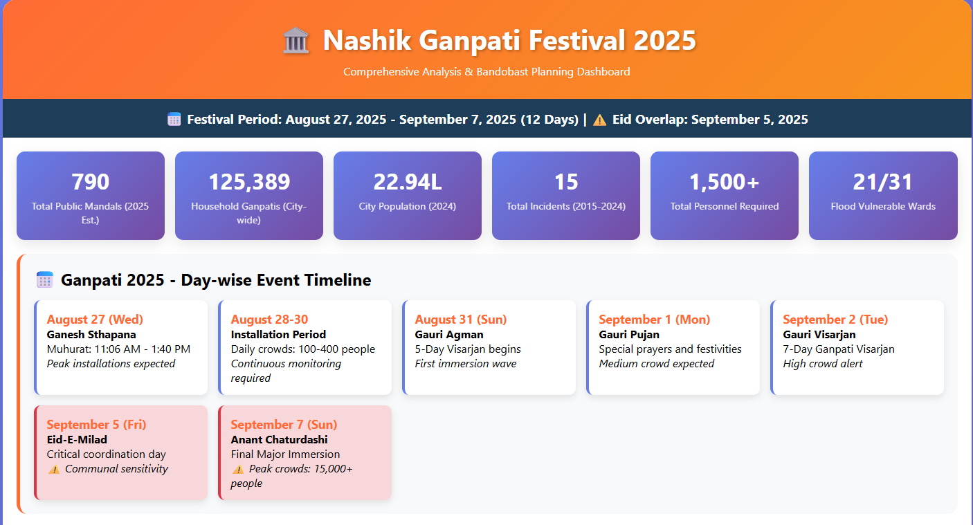
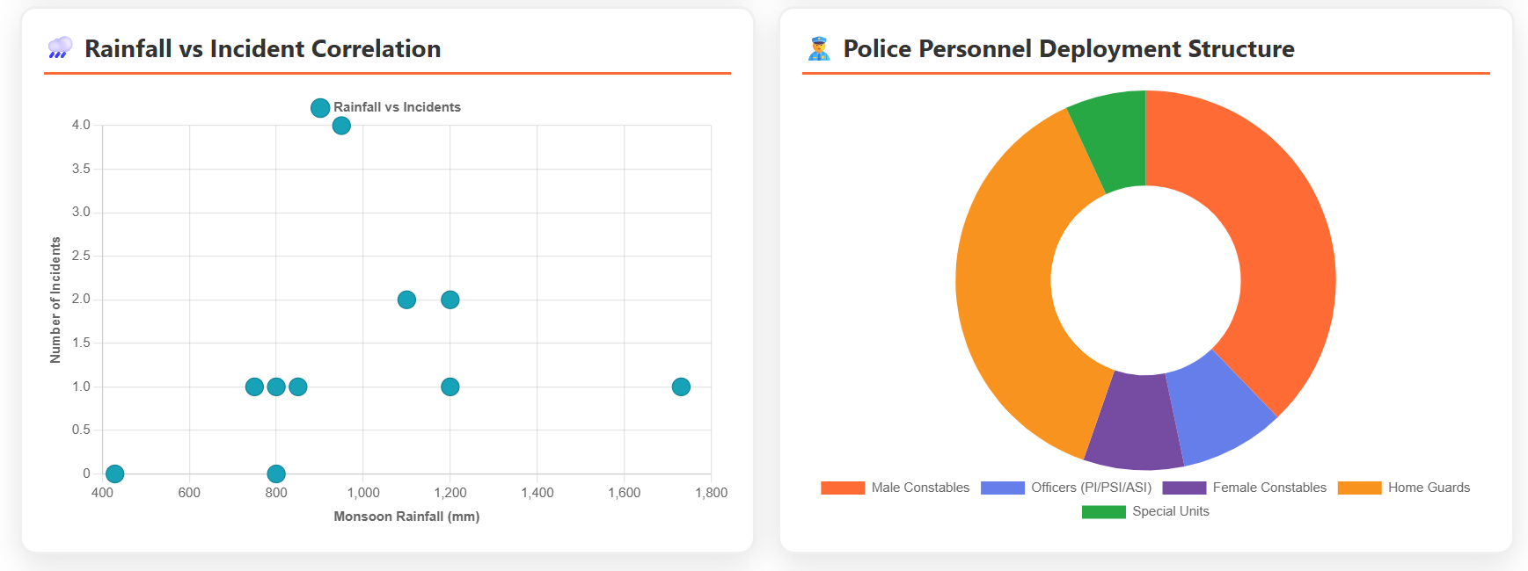

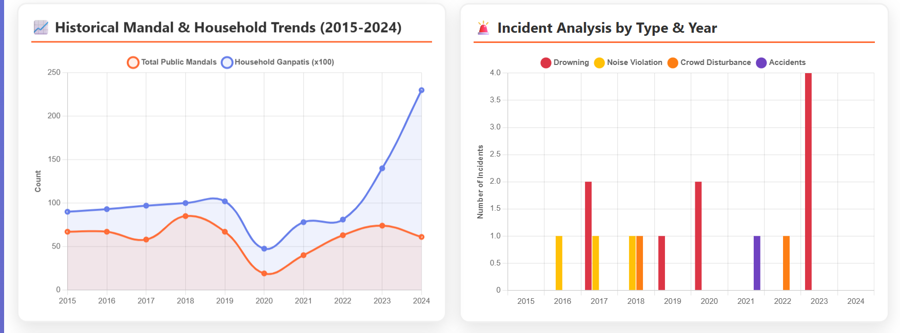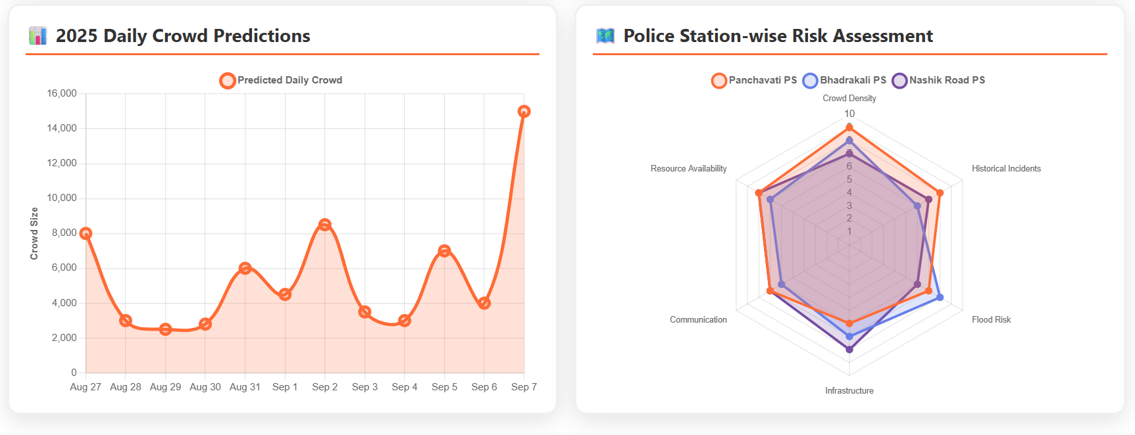

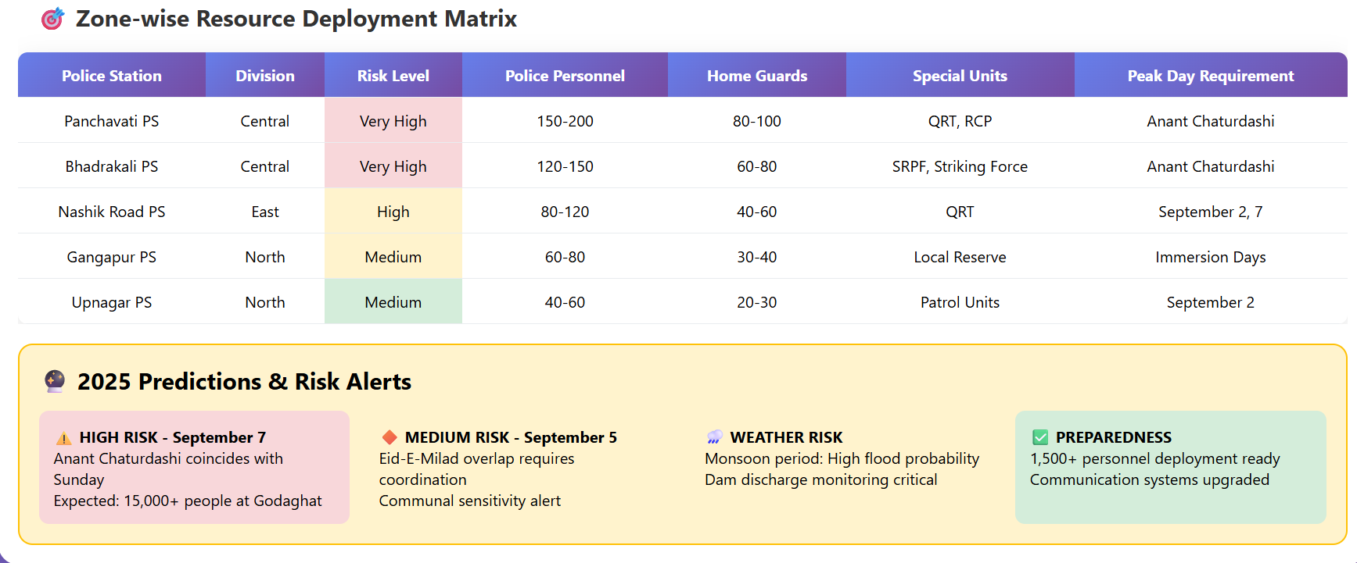

Responsive Link: - https://claude.ai/public/artifacts/31945eb7-563f-47b5-838b-5087900b8714

